**Punjab University College Of Information And Technology**



**Home Work (6)**

**Submitted By:**

**Submitted To:**

**Imran Mcsf19A027**

**Subject :**

**Haq Nawaz**

**Mobile Computing**



***Intent and Activities***

Activity manifest:

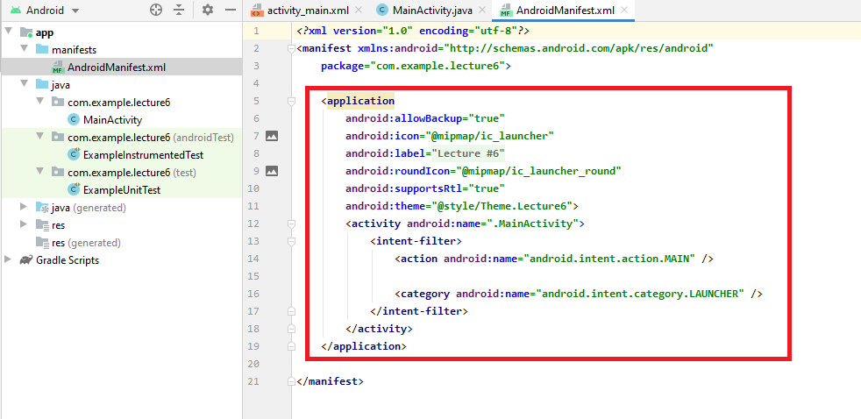

Add New Activity:

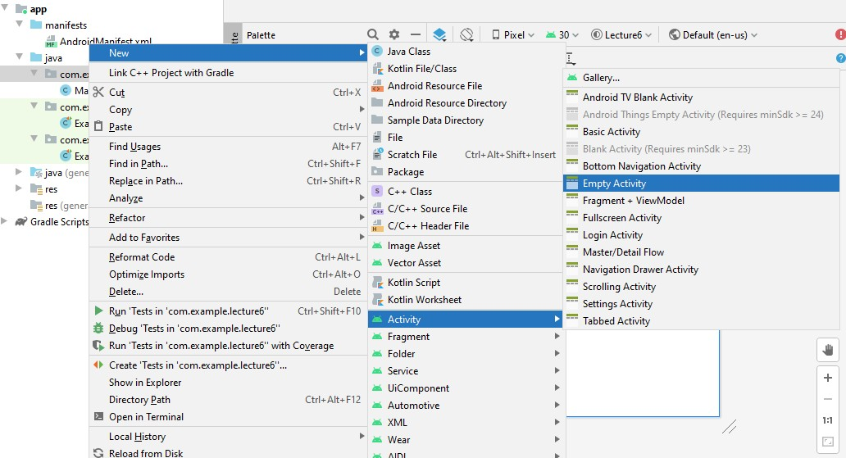

Add New Activity:

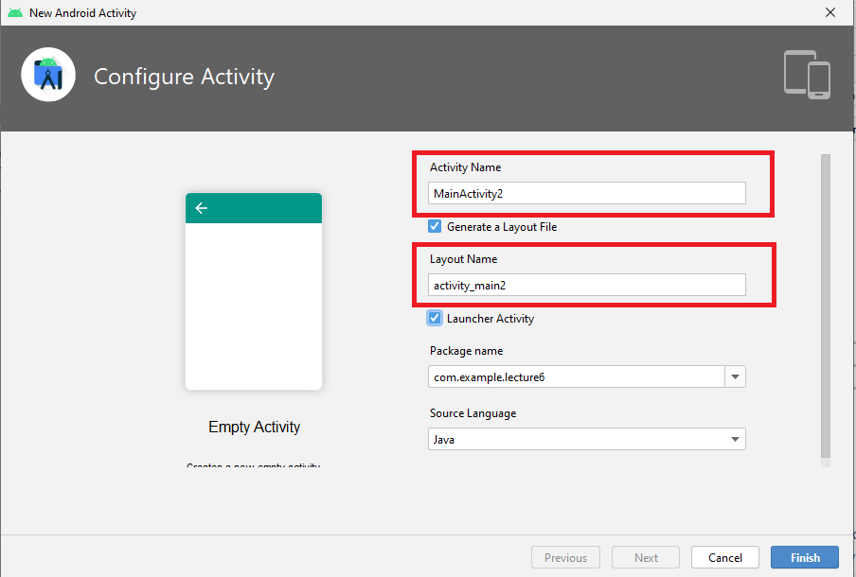

After Activity2 manifest:

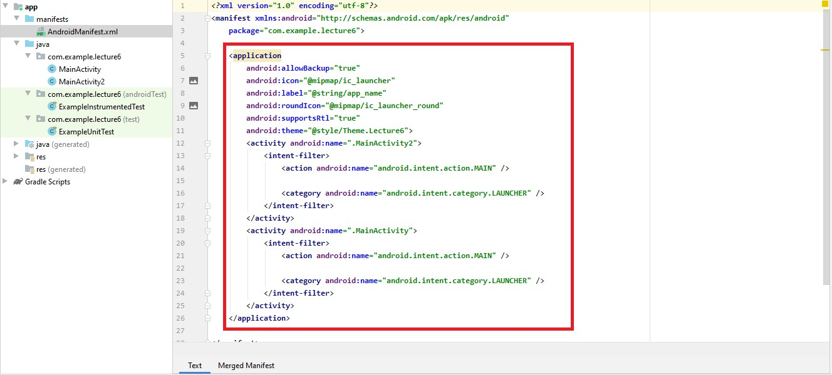

Files of GUI:

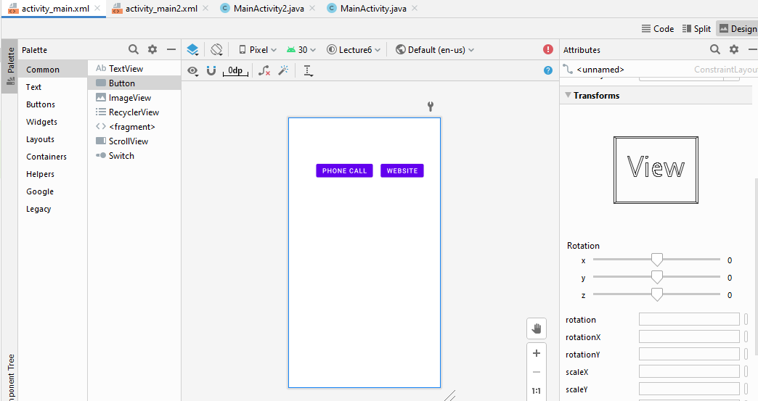

Implicit Intents - Examples:

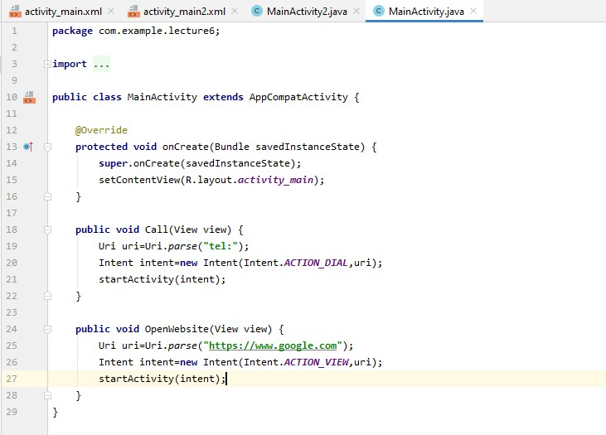

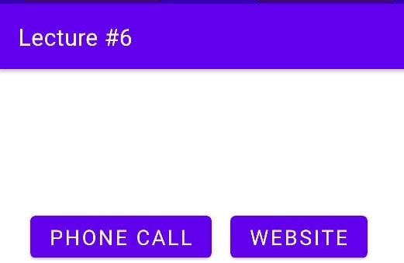

GUI files of Activity2:

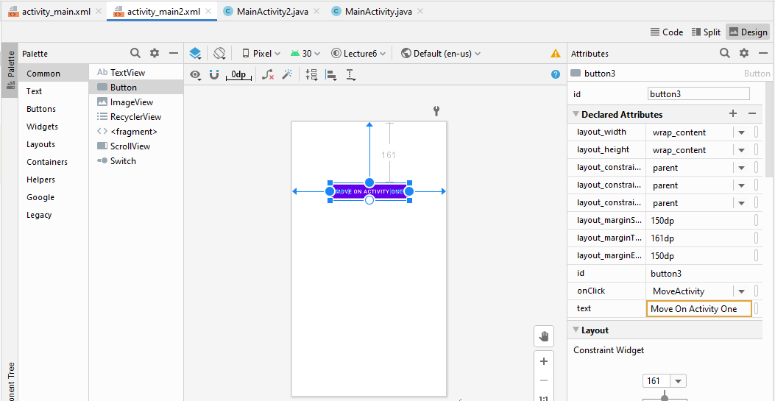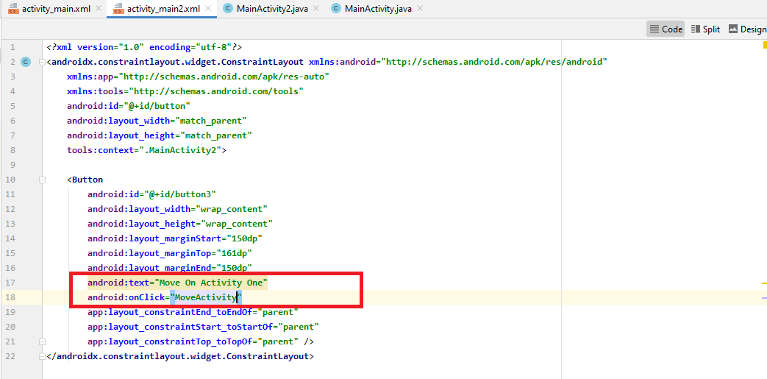

Code file of Activity2:

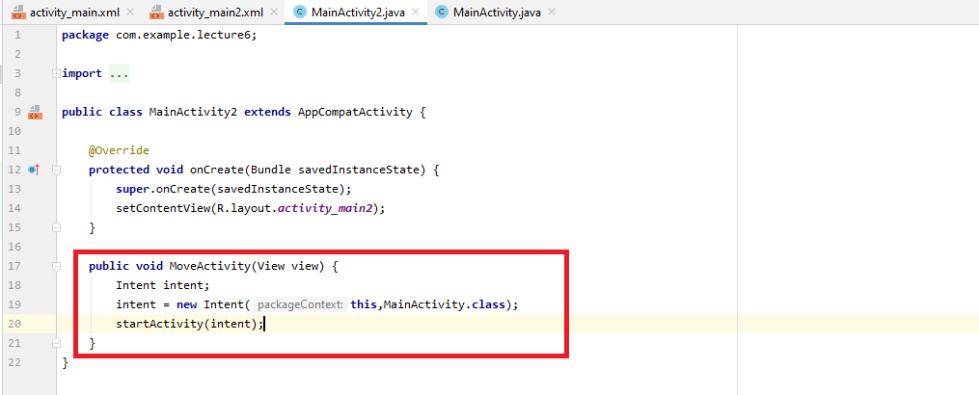

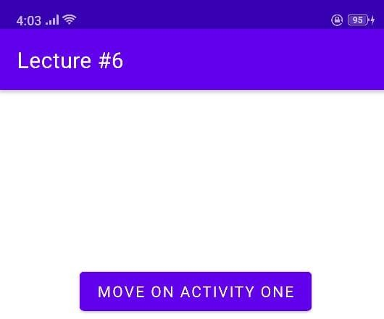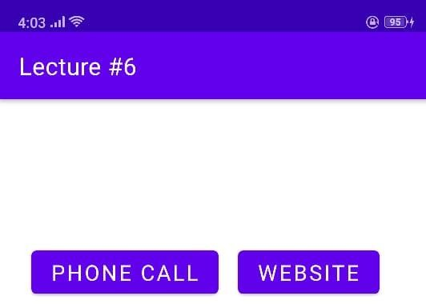

 

All Calls

¿ 0300

¿ Baba

0305644 7783

Amma



¿ 0230

.- Hum rn Uni

Edit





@ g google.co.m 



Google



Google offered in: y I

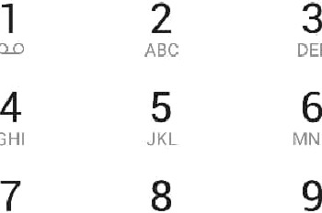

# 0 #

Cancel

Pakistan

Settings Prlvacy terms